Coursework 2 – Accessibility Report

**Module:**

**Web Technologies**

**SET08101**

**Karol Pasierb**

**40270305**

Software Engineering – Year 2

## Table Of Contents

##### Objective …………………………………………………………………………………………………………………..2

##### Conclusions ……………………………………………………………………………………………………………….2

##### Critical Analysis ………………………………………………………………………………………………………...2

##### Summary ……………………………………………………………………………………………….………………….3

##### Screenshots …………………………………………………………………………………………………………..….3

##### References …………………………………………………………………………………………………………….….5

## Objective:

To provide accessibility report and brief critical analysis of national student survey system electronic version at <http://40270305.soc-web-liv-06.napier.ac.uk/cw2/>. Describe what is webpage accessibility, why it is important and how can it be ensured.

## Conclusions:

According to W3C Easy Checks 4 website, page in question contains most of the required accessibility features. Page contains the title and it is displayed correctly. All Images contain alt text tag for text-to-speech. Headings are used in proper manner and order. There is only one h1 tag per page. Contrast ration is relatively good, however some improvement could be made. This issue is described below in critical analysis section. Resize text requirement is appropriately implemented. It works well when zooming the page as well as changing browser’s font display. Keyboard navigation is partially implemented and this seems to be area that needs most improvements in regards to providing full accessibility.

The page uses forms, labels and errors in functional manner. It doesn’t pose any problems at this point of development and works at required level. There are no aminations apart from blocks of content that might be closed and opened when needed. There is no moving, flashing or blinking content, that could be problematic for some users with particular impairments. This page do not contain any multimedia alternatives as the purpose of the page eliminates this need and replacement would not give requested results. This page is well displayed on various desktop screens as well as on mobile devices where the screen sizes vary more dramatically. Page in question is more accessible and readable on mobile devices as its layout is nicely spread on the screen and all elements are big and easy to read.

Accessibility validation for this prototype page was performed on 3 different online tools. Results are displayed below in screenshots section. Survey page passed fully 2 of 3 checks achieving WCAG 2.0 (AA Level). Third checked showed error H44 5 from the WCAG standard. This explains that according to this online validator there was one place where label and its for attribute were used incorrectly.

## Critical Analysis:

Student survey system allows user to complete the survey online. When the page is accessed at this point it doesn’t contain any sort of authorization system. It only asks about student number. This potentially allows user to enter someone else’s account and change or add their answers. More secure and reliable option would be to implement authorization within the University system and each survey would be matched to the students when they access their account.  
 The color scheme and layout is clear and looks good, however doesn’t seem to be very professional and appropriate for this particular use. Usually all online resources for formal and administration tasks are very plain and clear as the look and the design is less important on those pages. What matters most is the accessibility and operational features on those pages. Too complexed and colorful layout and design may confuse users and they may not be able to use those pages appropriately.  
 This student survey system allows users to navigate through the website quite easily and gives few options to adjust the view. Website basically explains its operation and actions needed to be taken, although this could also be improved to avoid as much confusion as possible.

When answers are submitted user is presented with the confirmation and information about next possible actions to take.

## Summary:

The design of the student survey system is good. It is relatively easy to read and follow. The appearance of the site is consistent throughout. Information is presented in logical manner. Navigating of the page is mostly intuitive, although contains few unnecessary features and design choices that could be avoided and/or simplified for better understanding of its purpose and easier to follow navigation and functionality.

Page passed WCAG accessibility validation and according to W3C Easy checks it conforms with most of required features on acceptable level. As this is the prototype of the system remaining features it allows for remaining features to be implemented in the final version of the page.

## Screenshots:

HTML 5 Validation

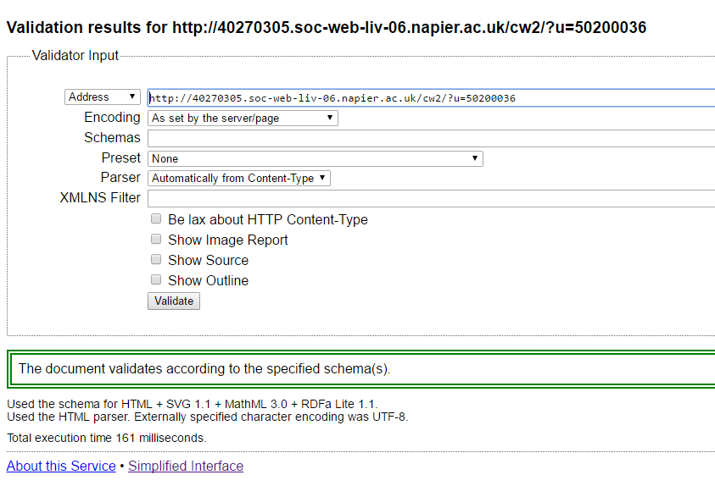

W3 HTML 4 Validation

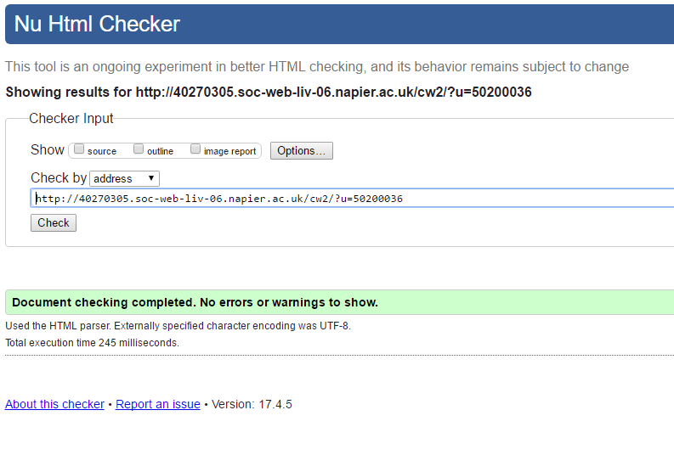

Accessibility Report from MAUVE Accessibility Validator 2

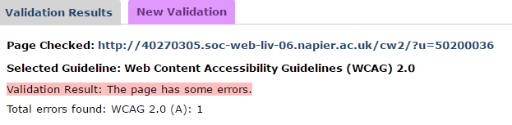

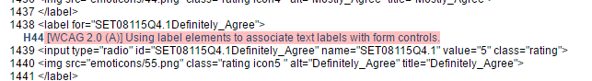

Accessibility Report from WAVE Web Accessibility Tool 3

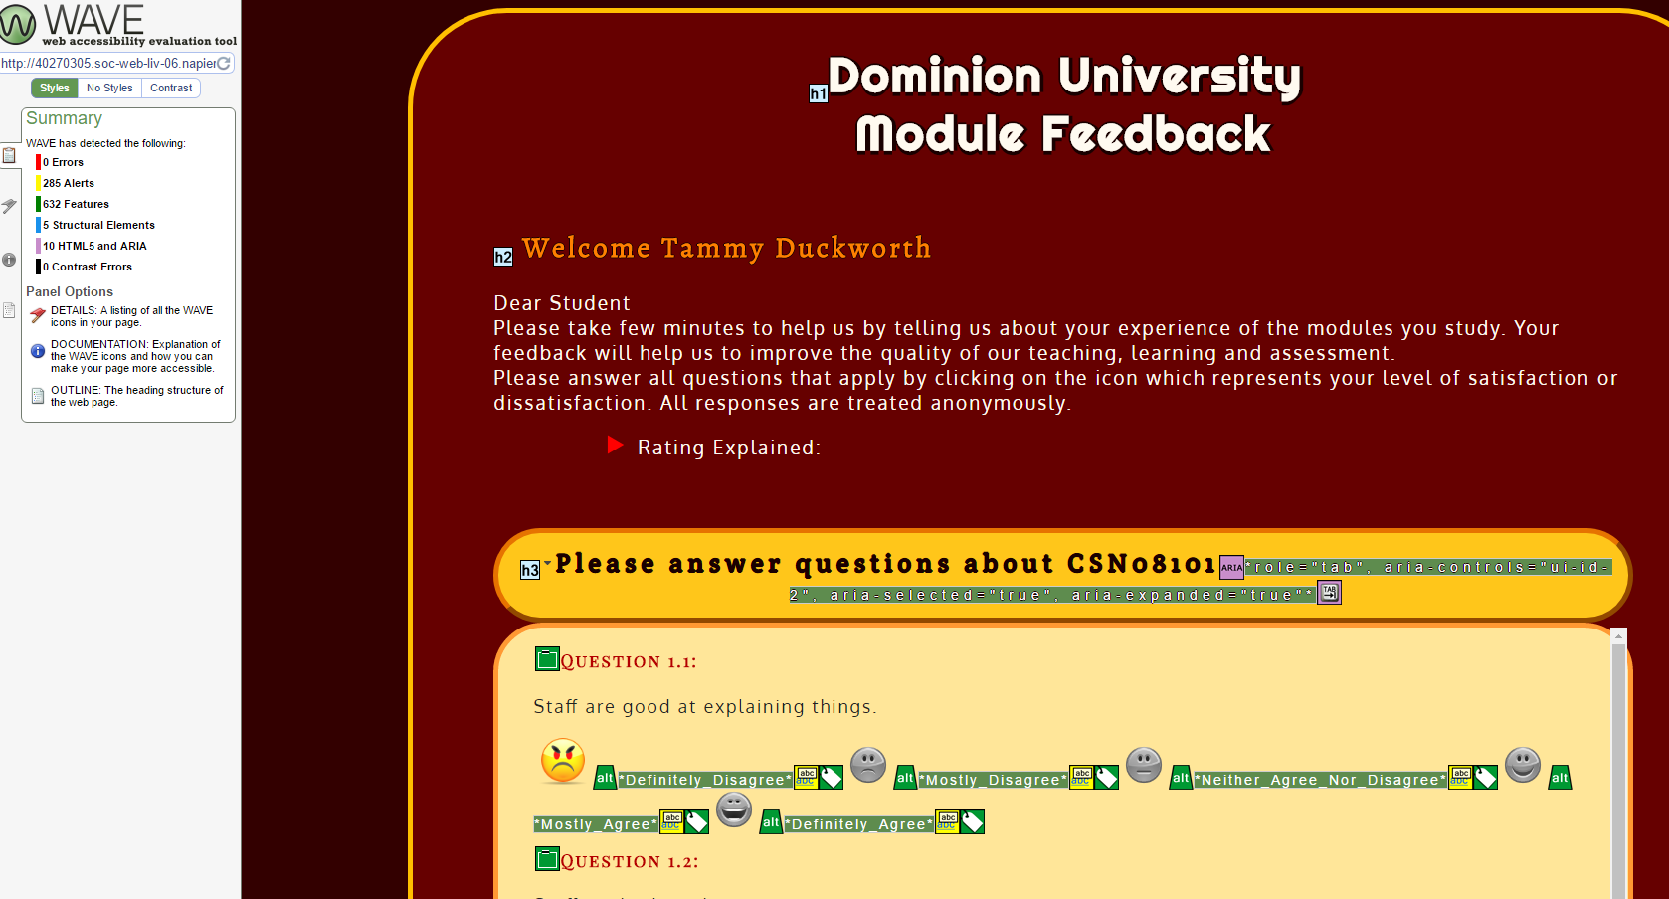

Accessibility Report from IDI Web Accessibility Checker 1  
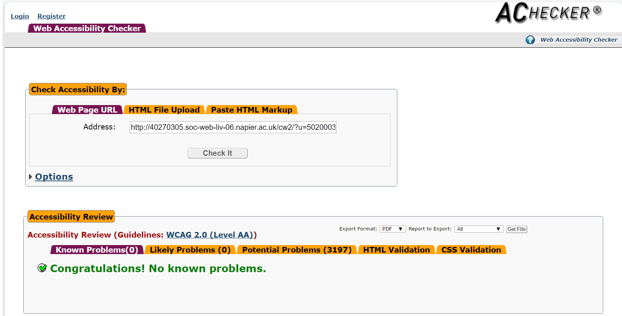

## References:

1. Achecker.ca. (2017). *IDI Web Accessibility Checker : Web Accessibility Checker*. [online] Available at: https://achecker.ca/checker/index.php [Accessed 5 Apr. 2017].
2. Giove.isti.cnr.it. (2017). *MAUVE Accessibility Validator*. [online] Available at: http://giove.isti.cnr.it:8080/MauveWeb/index.jsp [Accessed 5 Apr. 2017].
3. Wave.webaim.org. (2017). *WAVE Web Accessibility Tool*. [online] Available at: http://wave.webaim.org/ [Accessed 5 Apr. 2017].
4. W3C Web Accessibility Initiative (WAI). (2017). *Easy Checks - A First Review of Web Accessibility ◦ Web Accessibility Initiative ◦ W3C*. [online] Available at: https://www.w3.org/WAI/eval/preliminary [Accessed 5 Apr. 2017].
5. W3.org. (2017). *H44: Using label elements to associate text labels with form controls | Techniques for WCAG 2.0*. [online] Available at: https://www.w3.org/TR/WCAG20-TECHS/H44 [Accessed 5 Apr. 2017].